Asa Hayes CSCE-313-199 Ahmed 26 June, 2020

**Project 4: Report**

While I will still post graphs comparing the two transfer methods on time, behavior was as expected. TCP connections scaled at nearly the same rate as FIFO for all parameters at both data & file transfer. As TCP is a more complex implementation and also involves the actual transfer of data across a network rather than just across a few files like FIFO, performance would be expectedly worse. This would likely depend wholly on network conditions & stability, as otherwise operations followed the same patterns as observed and commented on as in my PA3 report.

As far as the maximum number of TCP connections, there is a theoretical limit of 65536 connections, but due to the inconsistent results of most classmates, I think there would need to be more of an in-depth look as to what the limit would be in our implementations.

All graphs contain same data from PA3, with PA4 results added for comparison.

Data Transfer Timing

P=5, N=15000, m=256 (default). All other parameters, increments, defaults were the same as PA3 testing for more effective comparison.

Change in w (threadcount); b=500

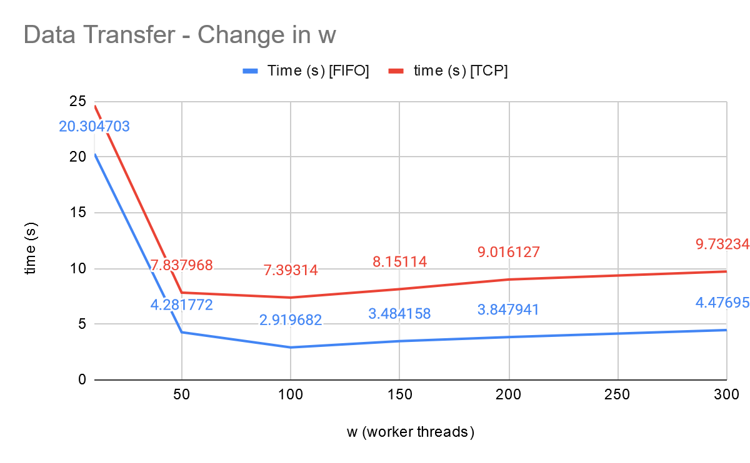

Change in b (buffersize); w=100

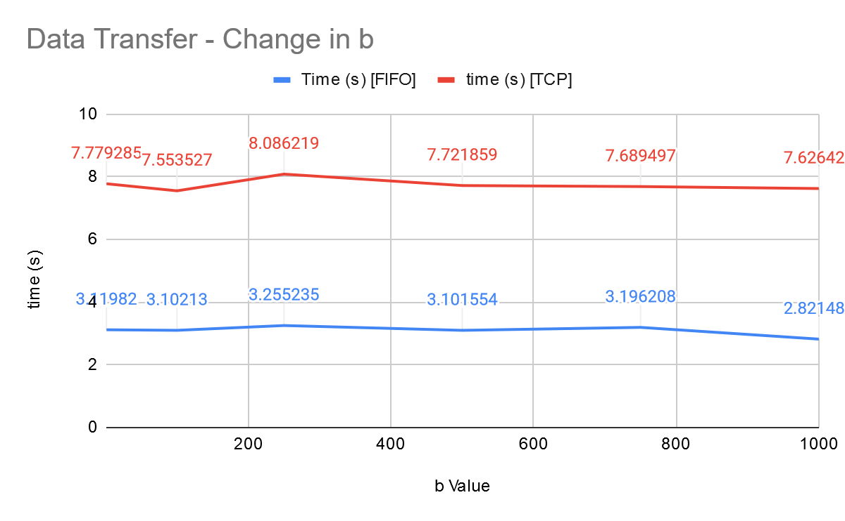

File Transfer Timing

File transferred was 10.csv. All other parameters, increments, defaults were the same as PA3 testing for more effective comparison.

Change in w (threadcount); b=500

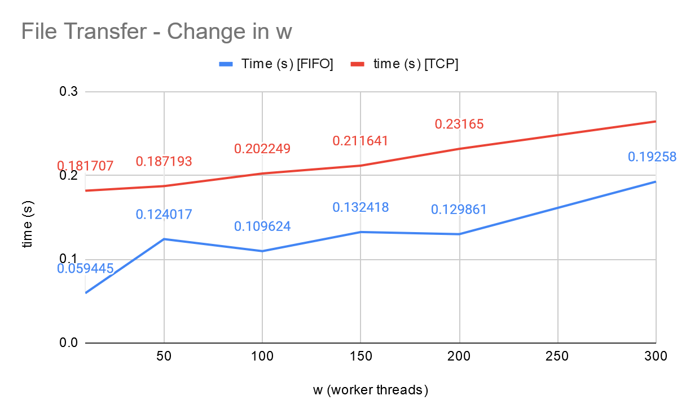

Note: The inconsistencies seen in time changes from PA3 have been reduced, creating a smoother, but still increasing line, as more worker threads than necessary still only lows down file transfers.

Change in b (buffersize); w=100

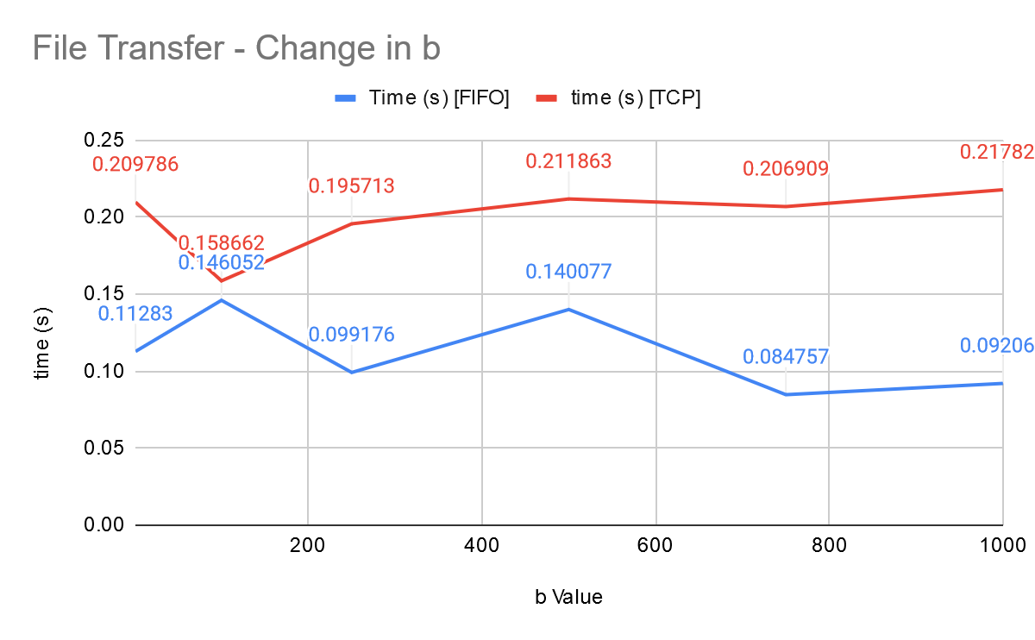

Note: While it does smooth out afterwards, I’m not sure of the reason for the large dip at b=100. Might have been some network jitter, or a continuation of the unsteady effect seen in in the FIFO implementation.